## BUS SEAT ALLOCATION

## SYSTEM

### **MINI PROJECT REPORT**

***Submitted by***

|  |  |
| --- | --- |
| **GOWTHAM K** | **(211031040)** |
| **AATHIRAMILAKI S** | **(211031001)** |

In Partial Fulfillment For The Award Of The Degree Of

### BACHELOR OF ENGINEERING

*in*

### COMPUTER SCIENCE AND ENGINEERING

**DEPARTMENT OF COMPUTER SCIENCE AND ENGINEERING**

### MAHENDRA ENGINEERING COLLEGE

(Autonomous)

### Mahendhirapuri, Mallasamudram, Namakkal DT - 637 503

### MAHENDRA ENGINEERING COLLEGE

#### (Autonomous)

Mahendhirapuri, Mallasamudram,

Namakkal DT -637 503

Department of **Computer Science and Engineering**

### BONAFIDE CERTIFICATE

Certified that this Report titled **“BUS SEAT ALLOCATION SYSTEM”** is the bonafide work of **GOWTHAM K (Reg. No. 211031040), AATHIRAMILAKI S (Reg. No. 211031001)** who carried out the work under my supervision. To the best of my knowledge, the work reported here does not form part of any other thesis or dissertation based on which a degree or award was conferred on an earlier occasion on this or any other candidate.

**SIGNATURE SIGNATURE**

**Dr.M.KANNAN, M.E., Ph.D, Mr.M.GOKULKANNAN**

**Head of the Department, Assistant Professor,**

Department of CSE, Department of CSE,

Mahendra Engineering College, Mahendra Engineering College,

Namakkal- 637 503. Namakkal- 637 503.

### **MAHENDRA ENGINEERING COLLEGE**

**(Autonomous)**

**Mahendhirapuri, Mallasamudram, Namakkal DT -637 503 Department of Computer Science and Engineering CERTIFICATE OF PROJECT APPROVAL**

This is to certify that the Project report Phase – I titled

**“BUS SEAT ALLOCATION SYSTEM”** is the approved record of work done by **GOWTHAM K (Reg. No. 211031040), AATHIRAMALAKI (Reg. No.211031001)** in partial fulfillment for the award of the Degree of Master of Engineering in **COMPUTER SCIENCE AND ENGINEERING** during the academic year 2023- 2024.

# ACKNOWLEDGEMENT

Behind every achievement lies an unfathomable sea of gratitude to those who actuated it. Without them, it would never have existed. To them I lay the word of gratitude imprinted within me.

I am delighted to thank **Shri M G BHARATH KUMAR, M.A., B.Ed., Chairman, Mahendra Educational Trust** for his blessings and constant support over my project period.

I wish to express my sincere thanks to **Dr R V MAHENDRA GOWDA, M.Tech., Ph.D. (IITD), Principal, Mahendra Engineering College** for his blessings and help provided during the period of my project work.

My heartfelt gratitude to **Dr M KANNAN, M.E., Ph.D., Head of the Department, Computer Science and Engineering** for his excellent guidance, sustained inspiration, constant help and timely encouragement throughout the tenure of the dissertation work.

I record my deep thanks to my Project Guide **Dr M KANNAN, M.E., Ph.D., Head of the Department ,** for his help and excellent cooperation in leading my project work.

We are immensely indebted to our project coordinator **__________________**, for the valuable guidance, support and motivation during the entire course of the project work.

I would like to extend my sincere thanks to all lab technicians for helping me in this venture, Unflinching support and encouragement from the members of my family, friends and staff members in **MAHENDRA ENGINEERING COLLEGE (AUTONOMOUS)** helping me a long way to complete my project work. I thank them all from the bottom of my heart.

# MAHENDRA ENGINEERING

# COLLEGE

## (AUTONOMOUS)

**DEPARTMENT OF COMPUTER SCIENCE AND ENGINEERING**

##### VISION

* To produce competent computer engineers proficient with state-of-the-art technologies

##### MISSION

* To impart good quality technical education through effective teaching-learning process
* To enhance the student’s employability through mentoring and skill development
* To promote innovation and research activities with analytical skills to face global challenges
* To enable students, imbibe ethical and enterprising characteristics to become socially responsible engineer.

**PROGRAM OUTCOMES (POs)**

**At the time of graduation, students from the Computer Science and Engineering program will possess:**

Engineering Graduates will be able to,

1. **Engineering knowledge:** Apply the knowledge of mathematics, science, engineering fundamentals, and an engineering specialization to the solution of complex engineering problems.
2. **Problem analysis:** Identify, formulate, review research literature, and analyze complex engineering problems reaching substantiated conclusions using first principles of mathematics, natural sciences, and engineering sciences.
3. **Design/development of solutions:** Design solutions for complex engineering problems and design system components or processes that meet the specified needs with appropriate consideration for the public health and safety, and the cultural, societal, and environmental considerations.
4. **Conduct investigations of complex problems:** Use research-based knowledge and research methods including design of experiments, analysis and interpretation of data, and synthesis of the information to provide valid conclusions.
5. **Modern tool usage:** Create, select, and apply appropriate techniques, resources, and modern engineering and IT tools including prediction and modeling to complex engineering activities with an understanding of the limitations.
6. **The engineer and society:** Apply reasoning inform informed by the contextual knowledge to assess societal, health, safety, legal and cultural issues and the consequent responsibilities relevant to the professional engineering practice.
7. **Environment and sustainability:** Understand the impact of the professional engineering solution societal and environmental contexts, and demonstrate the knowledge of, and need for sustainable development.
8. **Ethics:** Apply ethical principles and commit to professional ethics and responsibilities and norms of the engineering practice.
9. **Individual and team work:** Function effectively as an individual, and as a member or leader in diverse teams, and in multidisciplinary settings.
10. **Communication:** Communicate effectively on complex engineering activities with the engineering community and with society at large, such as, being able to comprehend and write effective reports and design documentation, make effective presentations, and give and receive clear instructions.
11. **Project management and finance:** Demonstrate knowledge and understanding of the engineering and management principles and apply these to one’s own work, as a member and leader in a team, to manage projects and in multidisciplinary environments.
12. **Life-long learning:** Recognize the need for, and have the preparation and ability to engage in independent and life-long learning in the broadest scontext of technological change.

**Program Educational Objectives (PEOs)**

The graduates of Computer Science and Engineering will be able to,

**PEO1** - Good communication, leadership and entrepreneurship skills

**PEO2** - Expertise on advanced computer technologies to become competitive

**PEO3** - The habit of learning and nurture the research attitude

**PEO4** - The ability to work in a team with professional ethics

**PROGRAM SPECIFIC OUTCOMES (PSOs)**

Engineering Graduates will be able to,

**PSO1 -** Ability to comprehend the underlying principles and systematic methods for the development, operation and maintenance of software, using professional engineering practices.

**PSO2 -** Ability to develop socially acceptable technical solutions to real world problems with various strategies for sustainable development.

**PSO3 -** Ability to apply the skills in the areas related to Algorithms, Networking, Web Designing, Artificial Intelligence, Internet of Things and Data Analytics of various complexities towards successful employment.

INTRODUCTION

Are you looking for Bus management system project? We are here to help you. You. Buses are the most frequently available and most used vehicle for going from small distance trips to very long trips. They’re a no. of types of buses available in the market according to the private or public. According to ac or no ac. Apart from this interstate, shrines, or inter-country also possible.

What the problem here arises about the ticket is everyone has to take a card and want seats. But it’s not possible. The buses which will register on our system will have the option to give their customers an option to select the seats of the bus according to their wish as many places depending on the availability.

Making the system more useful unique tickets will be generated as its seats are confirmed. Here we are with a system that can facilitate the users to which they can get their seats prior. As staff will decide the seat availability and here, we have other users like the staff of the bus and driver with the owner who together collaborates in smooth functioning of the bus ticket booking system.

## Modules of Bus Management System

The module of the bus management system is made of a combination of modules that work in collaboration with each other and make it beneficial to accomplish the main aim of the scheme.

### Ticket Booking:

This module of the project is for the users who want to book the tickets for the journey they want to do at the time of their desire. They fill the details accordingly like time of travel no. Of the people they want to go they select the seats which are available for the booking as the seats which are booked already will be blocked, they’re and the remaining seats are available.

### Payment:

They may make payment online through their debit card they use this module to pay as the ticket shows the amount in the account of the owner of the bus. As he makes the payment, the card becomes confirmed and ready to be used.

### Ticket Checking:

The verification of the cards is done by the conductor of the bus, he comes to the user and asks for a ticket no. As they take it, he checks and confirms their booking and lets them ride.

### Registration:

Users’ information has to be compelled to be registered within the system thus on establish every one of them unambiguously and do the required group acts as the real potential. Like on the name of the bill are issued. On the far side, this plenty of things require measure there wherever we will reference him.

Without registration, there are a few options and pages one user can see which are landing on the home page and taking the features to read but he won’t be allowed to use those. For use, he will have to register. One person needs to put all the details correctly and precisely as it will be helpful in identifying them and believing that he is the real person who has booked for the same.

### Log in:

After registration one will register within the system because of the operator of the system either on behalf of the user. When this he has the different helpful interfaces accessible for any actions. Here either bride or groom both have to log in with their unique identity and passwords. After this, they will be directed to the primary user interface from where they have further options.

### Forgot password:

This is quite often that people tend to forget the password they keep for the login. So, this could be very tedious and hectic to recover the password manually in case if one needs to log in in an emergency. So, to overcome this problem we have this module named ass forgot a password, and using this module users can recover their password in seconds.

So here we need only to put our registered email Id and hit the enter. Then one confirmation email will go to the email where he may reset the password. In seconds one can use this module and get rid of the forgetting password problem.

### Admin:

Admin has the official powers to control the flow of the data from one part of the system to the other. He can manipulate the access of the users to the data. The primary purpose of this account is to make the user data relevant and then giving the inputs to the other interface module and make it work optimistically and get the timetable according to the wish we want to create for a particular type of inputs.

**System Requirement of The Bus Management System**

**It’s its type of minimum needs that we’d like to require care of:**

* The system wants a minimum of two GB of ram to run all the options sleek and unforeseen.
* It wants a minimum 1.3 gigahertz processor to run smoothly as else which will produce issues.
* The system must be operated by some approved person as wrong hands will build it happy-go-lucky.
* Rest is all up to the user’s usage can take care of the hardware.
* For security opposing anti-virus is suggested.

The system is made correctly, and all the testing is done as per the requirements. So, the rest of the things depend on the user, and no one can harm the data or the software if the proper care is done. All the attributes are working correctly, and if any error is found, then it can be removed easily.

## System Design of The Bus Management System

### Entity Bus Owner:

#### Primary Key Bus owner-id:

This is system generated and unique, which can be referenced in any other entity.

#### Bus owner name:

Bus owner name is taken from the user and fed into this it is properly validated so that no mistake happens.

#### Qualification:

The requirement is made to filter the events according to this so that the user does not need to filter out the events to register it makes this system more reliable and useful.

#### Number:

The phone number is taken here to keep the member updated and the confirmation of the event is also managed through this method.

#### Email:

Email is made to make member aware of new offers new events and for future references, it is also relevant.

#### Type:

The kind of user is mentioned here like is he a student, teacher or he is the vendor of any shop. According to this data, the discounts offers and other things are decided plus few other things of adjusting the task of the user also with this.

#### Address:

The location of the user is also mentioned here to make it accessible to the delivery and few other things too.

#### Brand name:

The buses are run on the base of the name written on that it’s like creating brand awareness in the customer’s eye so that they prefer them and remember them. The name needed is given by this brand name.

### Entity Ticket:

#### Source:

From where the bus needs to be bored.

#### Destination:

Till where the user needs to go.

#### No of persons:

The no. of persons for which the ticket is required to book

#### Cost:

Price at which the Total cost shows.

### Entity Bus:

#### Primary Key Bus-id:

This is system generated and unique, which can be referenced in any other entity.

#### Name:

Name of the bus to be written here to identify it from the far and removing the chance of heading to the wrong bus.

#### Bus no. :

The numbering of the buses is done and shown to them.

#### Size:

The size of the bus makes sense for better facilities and getting.

#### Type:

Is the bus ac or no ac depending on that the users may prefer the booking and cost vary accordingly?

#### Parking address:

Where the bus will be parked after working for its day. The place address is given here.

#### Fuel capacity:

The ability of the bus to carry fuel is provided here, as estimate the fuel cost and distance it can travel at one go and taking out profit details.

### Entity Seat:

#### Primary Key Seat-id:

This is system generated and unique, which can be referenced in any other entity.

#### Seat no.:

The seat no. for which is bookable is done numbering.

#### Status:

The position is available for booking or already booked is mentioned over here.

### Entity Payment:

#### Primary Key Payment-id:

This is system generated and unique, which can be referenced in any other entity.

#### User-id:

This is a reference key from the other object to link the data of that table. It is system generated unique identity number. This is used to uniquely identify every table in the database and perform the crud operation on it.

#### Ticket-id:

This is a reference key from the other entity to link the data of that table. It is system generated unique identity number. This is used to uniquely identify every table in the database and perform the crud operation on it.

#### Status:

Is the payment is done or not is given here.

### Entity Staff:

#### Primary Key Staff-id:

This is system generated and unique, which can be referenced in any other entity.

#### Staff name:

The team’s name is taken from the user and fed into this it is properly validated so that no mistake happens.

#### Qualification:

The requirement is made to filter the events according to this so that the user does not need to filter out the events to register it makes this system more reliable and useful.

#### Number:

A phone number is taken here to keep the member updated and the confirmation of the event is also managed through this method.

#### Email:

Email is made to make member aware of new offers new events and for future references, it is also relevant.

#### Type:

The kind of user is mentioned here like is he a student, teacher or he is the vendor of any shop. According to this data, the discounts offers and other things are decided plus few other things of adjusting the task of the user also with this.

#### Address:

The location of the user is also mentioned here to make it accessible to the delivery and few other things too.

### Entity User: –

User data have to be saved in this object, and all fields are required for this purpose which is taken from the user.

**Proper validation is checked, and the attributes are as follows:**

#### Primary Key User-id:

This is system generated and unique, which can be referenced in any other entity.

#### Username:

Username is taken from the user and fed into this it is properly validated so that no mistake happens.

#### Qualification:

The requirement is made to filter the events according to this so that the user does not need to filter out the events to register it makes this system more reliable and useful.

#### Number:

The phone number is taken here to keep the member updated and the confirmation of the event is also managed through this method.

#### Email:

Email is made to make member aware of new offers new events and for future references, it is also relevant.

#### Type:

The kind of user is mentioned here like is he a student, teacher or he is the vendor of any shop. According to this data, the discounts offers and other things are decided plus few other things of adjusting the task of the user also with this.

#### Address:

The location of the user is also mentioned here to make it accessible to the delivery and few other things too.

### Entity Admin:

#### Primary key admin:

This is the primary supervisor of all tasks happening in the bus management system for a long. It is system generated unique identity number. This is used to uniquely identify every table in the database and perform the crud operation on it. It is used to reference that table to any other table or any interface to show the data and support other entities.

It has all the power to make changes in the field of other tables. It grants the privileges to other users of the system that what kind of operations they can perform.

#### Logs:

The logs are saved here to analyse the system accordingly. The changes occur. For necessary changes.

#### Password:

A Strong password is recommended for this account as no one wants to get hacked and lose the sophisticated data.

#### Description:

Any relevant info. Regarding this statement is attributed in this.

**HARDWARE REQUIREMENTS**

# CPU type : i5 processor

# Clock speed : 3.0 GHz

# RAM size : 8 GB

# Hard disk capacity : 256 ssd

# Keyboard type : Internet keyboard

**SOFTWARE REQUIREMENTS**

# Operating System : Windows 10

# Language’s Used : PHP

# PHP version : 5.6,7.4

# Database : MySQL

# IMPLEMENTATION

# To reserve a bus ticket, customers just have to select a date, the start location and the end destination, and go through the intuitive step-by-step booking process. They can review all available seats at a glance and select seats easily.

# FUNCTION

# The purpose of an online booking system is to allow potential customers to self-book and pay through your website, securely store customer's data, manage your staff and keep your business running long after you've gone home for the day. And that just scratches the surface.

## USE CASE DIAGRAM:

A use case diagram doesn't go into a lot of detail—for example, don't expect it to model the order in which steps are performed. Instead, a proper use case diagram depicts a high-level overview of the relationship between use cases, actors, and systems. Experts recommend that use case diagrams be used to supplement a more descriptive textual use case.

UML use case diagrams are ideal for:

* Representing the goals of system-user interactions
* Defining and organizing functional requirements in a system
* Specifying the context and requirements of a system
* Modeling the basic flow of events in a use case

## 

## Activity diagram

Activity Diagrams describe how activities are coordinated to provide a service which can be at different levels of abstraction. Typically, an event needs to be achieved by some operations, particularly where the operation is intended to achieve a number of different things that require coordination, or how the events in a single use case relate to one another, in particular, use cases where activities may overlap and require coordination. It is also suitable for modeling how a collection of use cases coordinate to represent business workflows

1. Identify candidate use cases, through the examination of business workflows
2. Identify pre- and post-conditions (the context) for use cases
3. Model workflows between/within use cases
4. Model complex workflows in operations on objects
5. Model in detail complex activities in a high level activity Diagram

## 

## Class diagram

## A description of a group of objects all with similar roles in the system, which consists of:

## Structural features (attributes) define what objects of the class "know"

## Represent the state of an object of the class

## Are descriptions of the structural or static features of a class

## Behavioral features (operations) define what objects of the class "can do"

## Define the way in which objects may interact

## Operations are descriptions of behavioral or dynamic features of a class

## 

## Sequence diagram

## In software engineering, a sequence diagram or system sequence diagram (SSD) shows process interactions arranged in a time sequence. The diagram depicts the processes and objects involved and the sequence of messages exchanged as needed to carry out the functionality. Sequence diagrams are typically associated with use case realizations in the 4+1 architectural view model of the system under development. Sequence diagrams are sometimes called event diagrams or event scenarios.

## For a particular scenario of a use case, the diagrams show the events that external actors generate, their order, and possible inter-system events.[1] All systems are treated as a black box; the diagram places emphasis on events that cross the system boundary from actors to systems. A system sequence diagram should be done for the main success scenario of the use case, and frequent or complex alternative scenarios.

## 

## Communication diagram

## A communication diagram offers the same information as a sequence diagram, but while a sequence diagram emphasizes the time and order of events, a communication diagram emphasizes the messages exchanged between objects in an application. Sequence diagrams can fall short of offering the "big picture.”

## This is where communication diagrams come in and offer that broader perspective within a process. You can draw your own communication diagram using our free UML software.

## Communication diagrams offer benefits similar to sequence diagrams, but they will offer a better understanding of how components communicate and interact with each other rather than solely emphasizing the sequence of events. They can be a useful reference for businesses, organizations, and engineers who need to visualize and understand the physical communications within a program. Try drawing a sequence diagram to:

## 

### Functional requirements: –

The functional requirements of the bus management system are those requirements that are necessary to the eye of the user and the client. Here we try to make the module possible to accomplish the need of the desired function.

### Non-Functional requirements: –

These requirements need unit among the style of “system shall be “, associate overall property of the regime as a full or of a particular aspect and not an individual operates. The system’s overall properties remarkably mark the excellence between whether or not the event project has succeeded or unsuccessful.

### Non-functional needs –

**Bus management system unit of measurement usually divided into two main categories:**

* Execution qualities, like security and quality, that unit evident at the run time.
* Evolution qualities, like liabilities, maintainability, flexibility, and quantitative, that unit embodied among the static structure of the code.

Non-functional needs place restrictions on the merchandise being developed, the event technique, and specify external constraints that the merchandise has to be compelled to meet. Our project qualifies all the factors of helpful and nonhelpful consequently and the system is up to mark performance device. Here we’d prefer to need the care of few lots of things before heading towards the system.

The many sensible intuitive interfaces are usually created. that ultimately build interface easy to use for a lengthy time. in distinction to ancient vogue wherever the goal is to create the difficulty or application physically enticing, the goal of interface vogue is to create the user’s interaction expertise as straightforward and intuitive as doable – what’s typically mentioned as user-centered vogue.

Where smart graphic/industrial vogue is daring and eye-catching, intelligent interface vogue is sometimes delicate and invisible.

.

**FINAL OUTPUT**

**Step 1:**

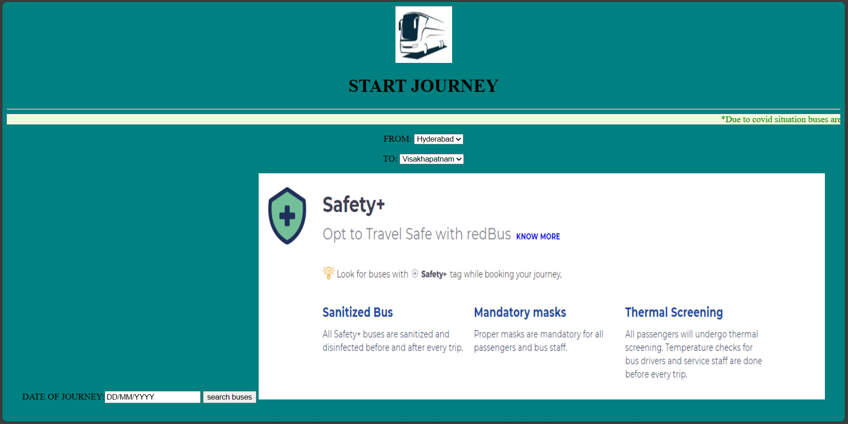

**Step 2:**

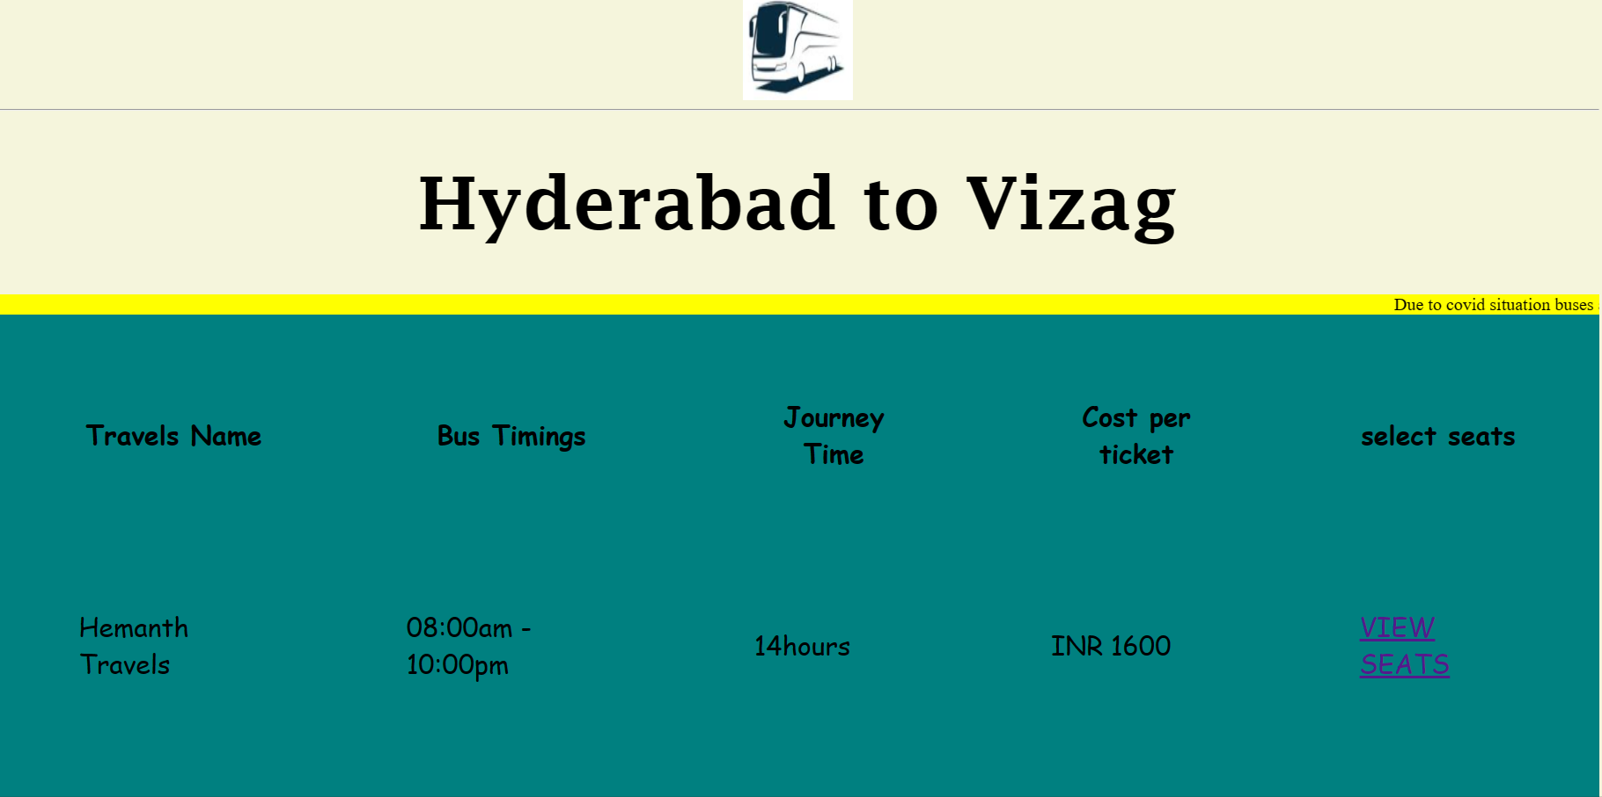

**Step 3:**

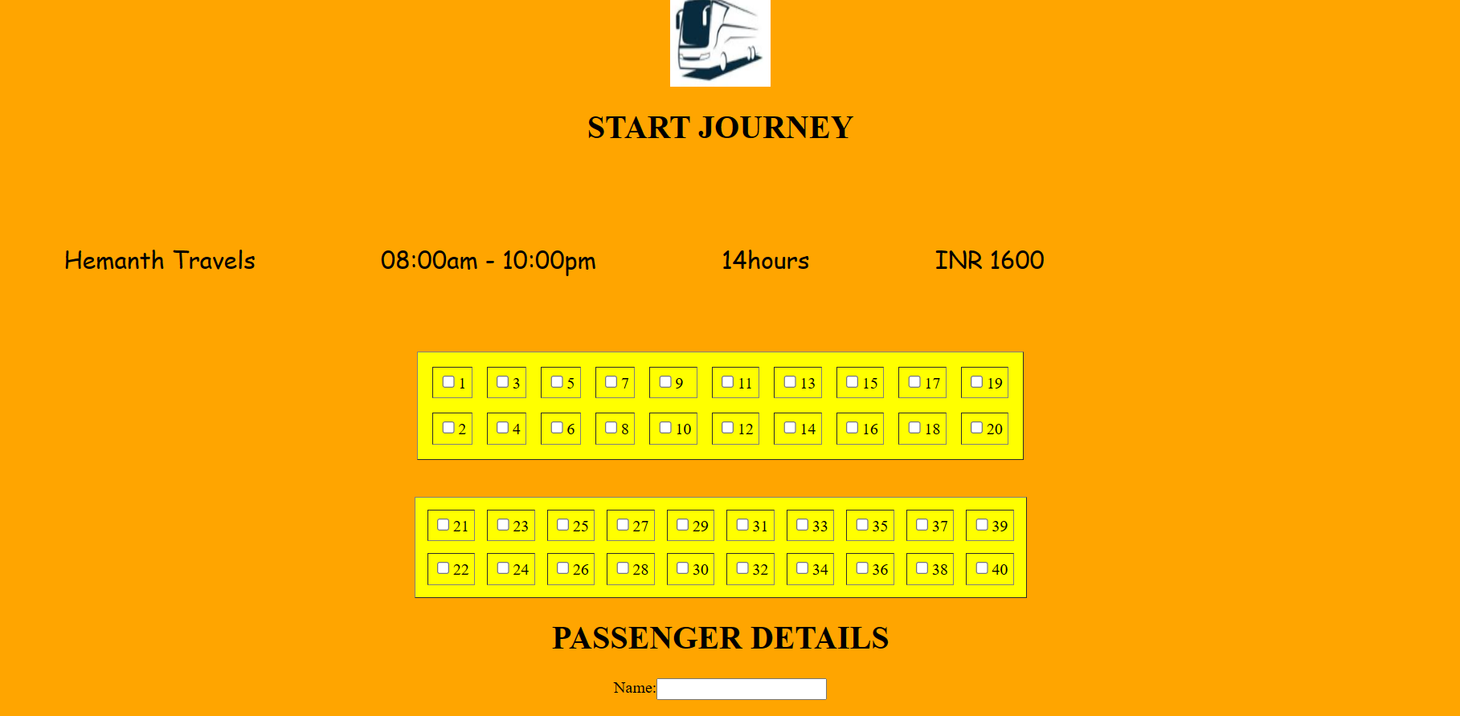

**Step 4:**

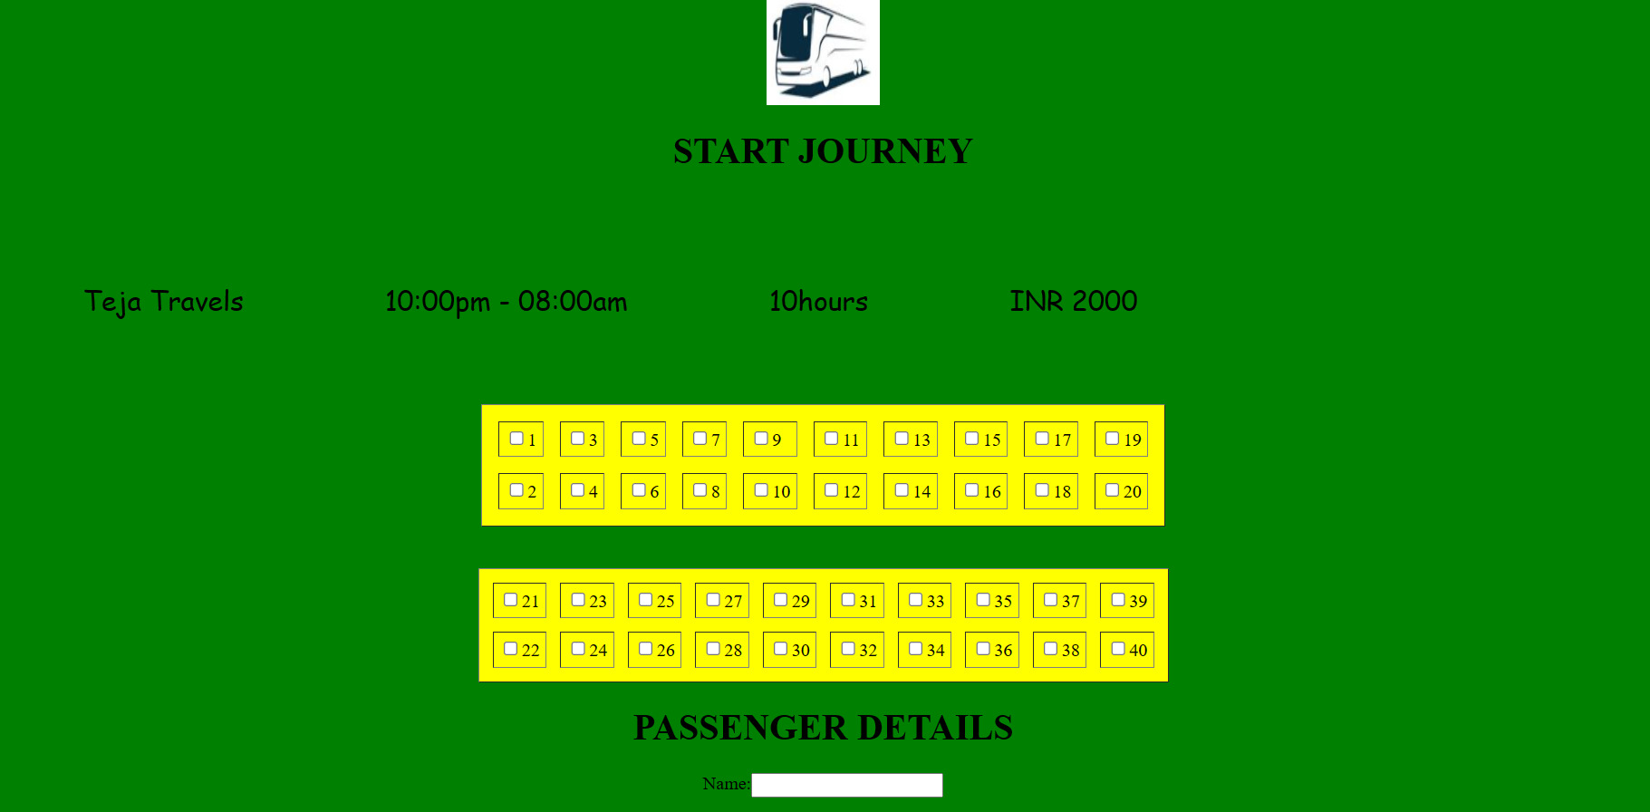

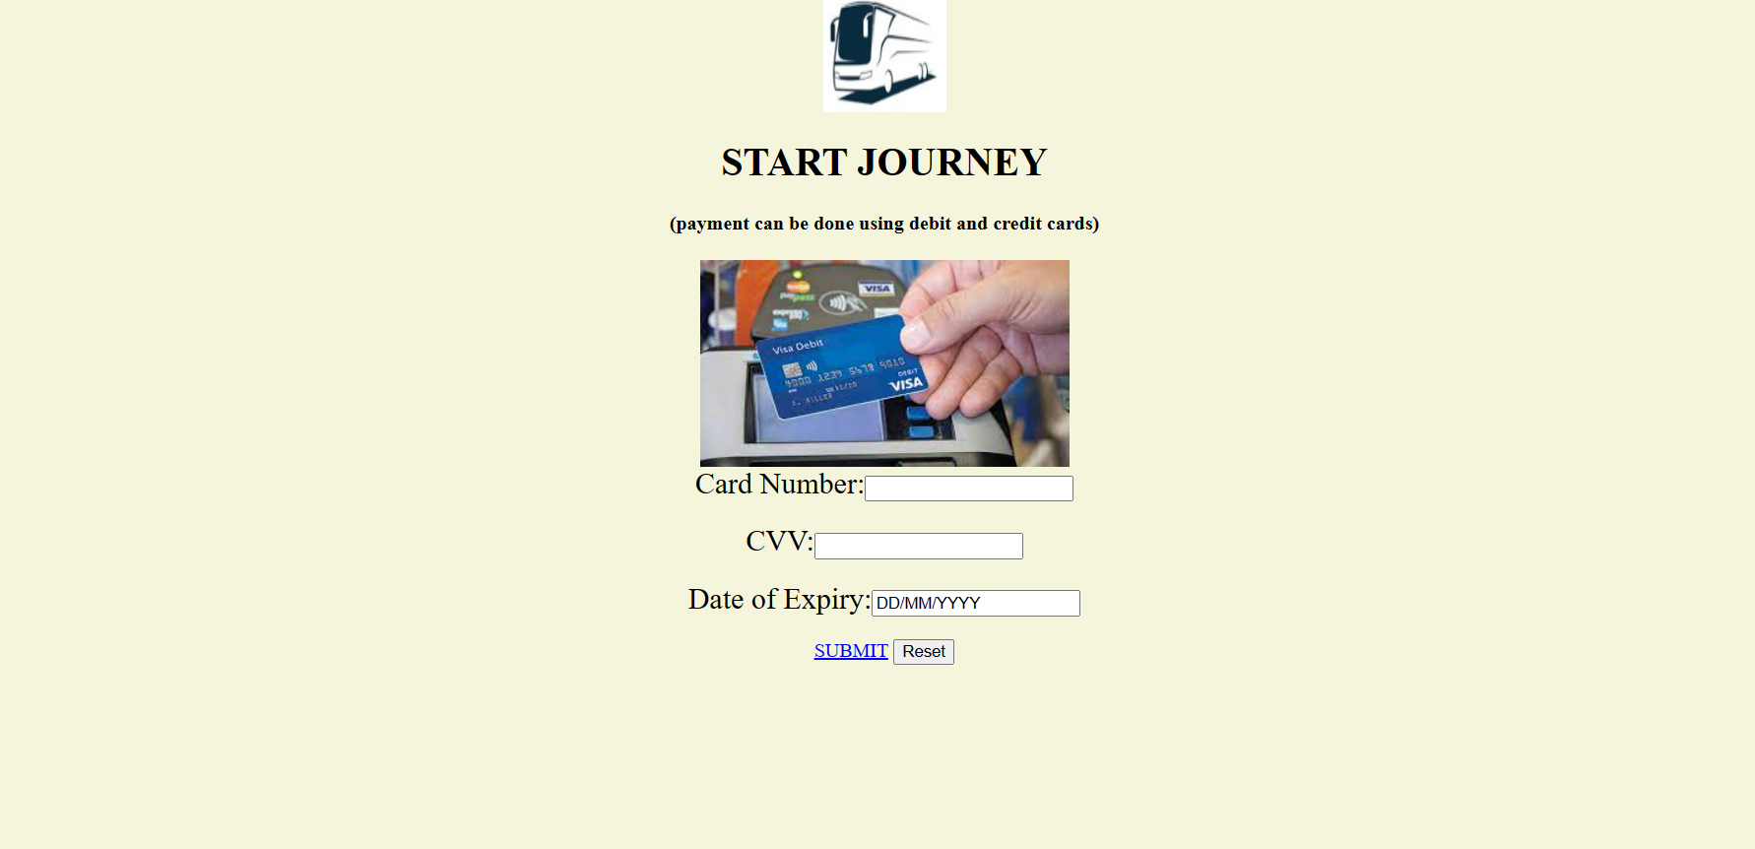**Step 5:**

**Step 6:**

